PROJECT REPORT

Library Management System  
for the partial fulfillment of the requirement

for the award of the degree of

BACHELOR OF TECHNOLOGY

IN

COMPUTER SCIENCE AND ENGINEERING

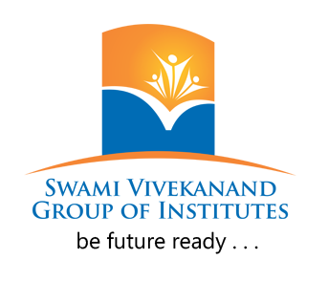

Swami Vivekanand Institute of Engineering and Technology

Session 2021-2025  
  
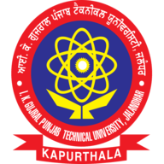

SUBMITTED BY:-

Rahul Thakur Sharma (2108121)

Pranav Kumar (2108107)

Batch :- 2021-2025 (8th Semester)

**CERTIFICATE**

**This is to certify that the project report under titled as**Library Management System

**is the Bonafide work of**

**Rahul Thakur Sharma(2108121),  
Pranav Kumar(2108107)**

**conducted under our direct supervision and guidance.**

**No part of this work has been submitted for any other degree of any other university. It may be considered for the evaluation in the partial fulfillment of requirement for the award of degree of**

**Bachelor of Technology in Computer Science and Engineering at**

**Swami Vivekanand Institute of Engineering and Technology**

**in the academic session 2021-2025.**

Professor (C.S.E Branch) H.O.D of Computer Sc. Dept.

Date: 28-May-2025 Date: 28-May-2025

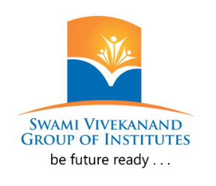

**Faculty of Technology**

**Department of Computer Science & Engineering,**

**Swami Vivekanand Institute of Engineering and Technology**

**Ramnagar, Banur-140601**

**May 2025**

**Acknowledgement**

We (**Rahul Thakur Sharma** & **Pranav Kumar**) deem it a pleasure to express my sincere gratitude to our project guide, **Mrs. Manmeen**, Professor under whose guidance we carried out this project. Her incisive insights, objective feedback, and timely advice continuously encouraged us and provided the motivation to persevere through every stage of the work.

We would also like to extend our heartfelt thanks to **Ms. Sapna**, Head of the Department, *Computer Science and Engineering*, for her valuable suggestions and encouragement, which played a vital role in the successful completion of this project.

We remain deeply grateful to **Mr. Vivek Madan**, Professor for fostering a strong academic environment and enforcing the discipline that enabled us to complete the project with focus and dedication.

Lastly, We would like to express our special thanks to our parents and friends for their unwavering love, support, and encouragement throughout the entire duration of the project. Their sacrifices and constant care have been our greatest strength.

Date: **28.05.2025**

Place: **SVIET College, Banur, Punjab**